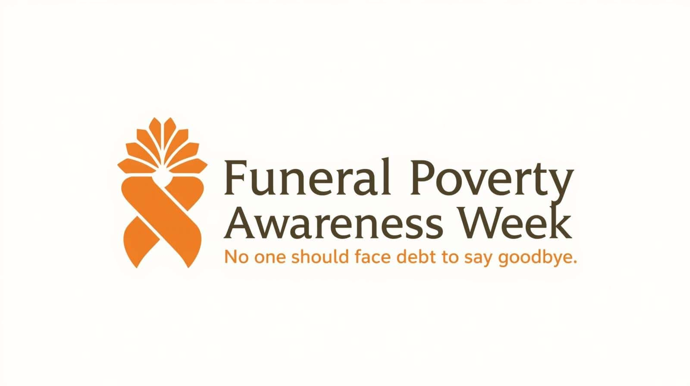
3–9 February 2026
Key Concerns About Funeral Poverty
Funeral poverty is not just about the cost of a funeral. It is about what happens to families when they are forced to make urgent decisions at one of the most difficult times in their lives.
The cost of funerals is too high for many families
- The average cost of a funeral in the UK is now over £4,000
- Costs have risen faster than wages and benefits
- Many families simply do not have savings to cover this
For some, a funeral becomes the biggest bill they will ever face.
Families are taking on debt at a time of grief
- Many people rely on credit cards, loans, or borrowing to pay for a funeral
- Government support often does not cover the full cost
- Payments are usually received 4–6 weeks after the funeral, but most funeral directors require full payment upfront
This means families can be left with debt that lasts long after the funeral.
People often feel they have no real choice
- Grief, shock and time pressure make it hard to compare prices
- Many people believe funeral prices are fixed
- Some worry that choosing a lower-cost funeral is disrespectful or means lesser quality of service
As a result, people may agree to costs they cannot afford.
Funeral prices can vary significantly
- Families can be charged over £1,000 more for similar funeral services
- Prices are not always easy to find or compare
- Even where pricing is published, it can be confusing and overwhelming
This makes it difficult for people to make informed decisions.
Support is not always easy to access
- Help with funeral costs depends on strict eligibility rules
- Many working families do not qualify
- People are often unaware what their options are and what support is available
Families may only discover this after it is too late.
Funeral poverty has a lasting impact
- Financial pressure and debt can cause additional stress, anxiety and contribute to complex grief
- People report feelings of shame, guilt and isolation
- Financial pressure can affect mental and physical health, employment and relationships
The effects of funeral poverty can last long beyond the funeral itself.
Why awareness matters
Funeral poverty can be preventable. With better information, earlier support, and fairer systems, families can be protected from unnecessary debt at a time when they are most vulnerable.
#FuneralPovertyWeek #NoDebtToSayGoodbye #FairFunerals
Free helpline: 0800 086 8887 | funeralexperts.com

