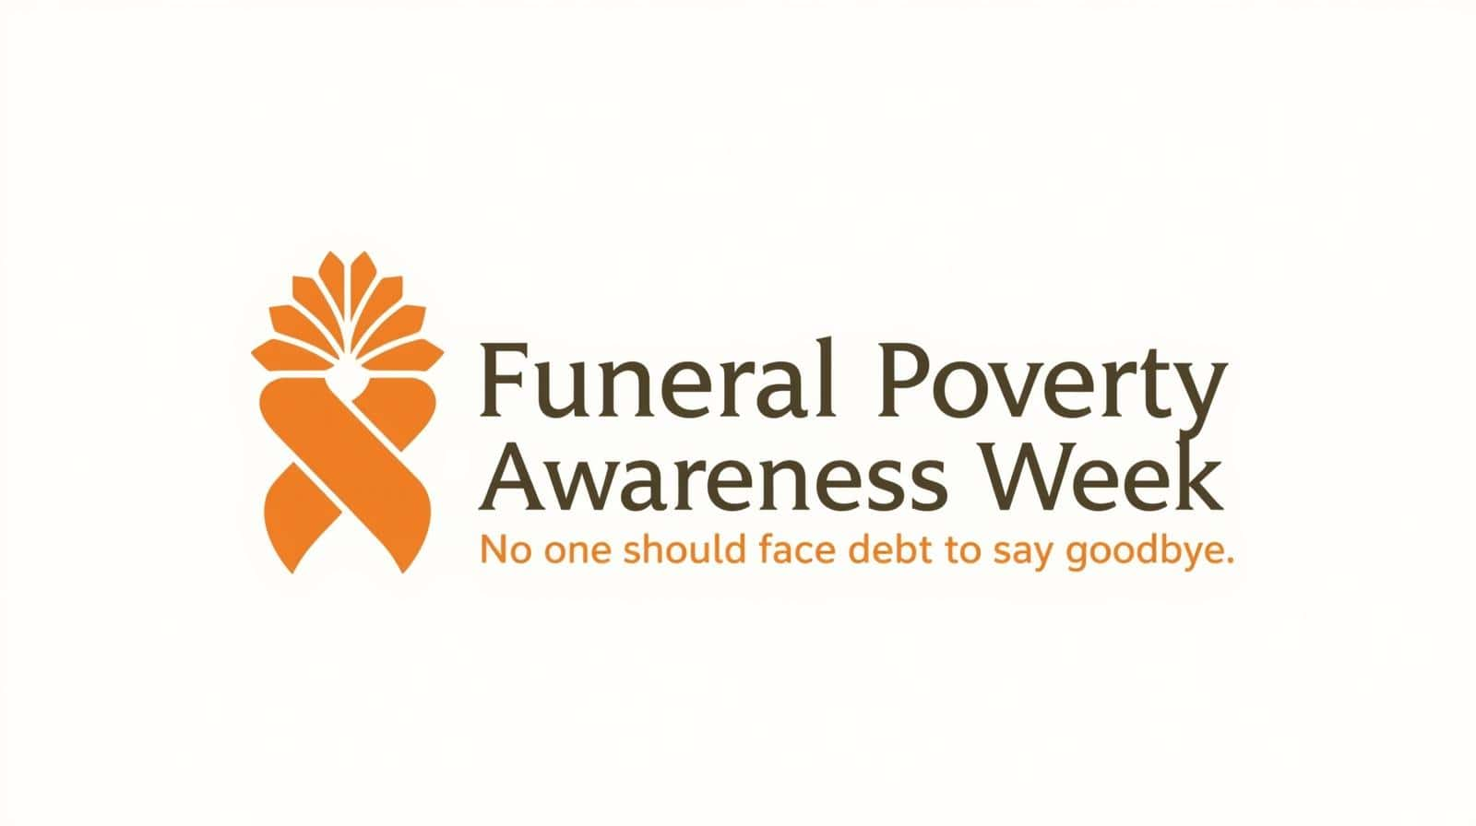
3–9 February 2026
Partner Information and Shareable Content
Partner Invitation
Funeral Poverty Awareness Week takes place from 3–9 February 2026 and aims to raise awareness of the financial challenges many families face when arranging a funeral.
With the average funeral now costing over £4,000, many people are required to make difficult financial decisions at a time of grief. Time pressure, uncertainty about costs, and a lack of clear information about available support can make it harder for families to feel confident about their choices.
The campaign aims to:
- Raise awareness of the challenges families face
- Help people understand their rights and options
- Encourage fair pricing, clear information, and better signposting
- Protect vulnerable people from harmful or predatory lending
Organisations can support the campaign by sharing information with their networks, displaying materials for service users, or helping to raise awareness through their own communication channels.
A full campaign toolkit is available, including social media graphics, key messages, and suggested posts.
If you are interested in supporting Funeral Poverty Awareness Week or would like to discuss partnership working, please get in touch.
Free helpline: 0800 086 8887 | funeralexperts.com
Information for Service Users and Networks
This week, from 3–9 February, is Funeral Poverty Awareness Week.
Many families struggle with the cost of funerals. The average funeral now costs over £4,000, and many people are unaware of the choices available to them or the help they may be entitled to.
Key information to share:
- You can ask for an itemised quote from any funeral director
- Prices can vary by hundreds of pounds for similar services
- Financial help may be available, depending on your circumstances
- High-risk or illegal lenders should always be avoided
Free and confidential support is available:
Funeral Experts Helpline: 0800 086 8887
Stop Loan Sharks: 0300 555 2222
Please share this information with anyone who may benefit.
Newsletter Copy
Funeral Poverty Awareness Week runs from 3–9 February 2026.
The average funeral in the UK now costs over £4,000. For many families, this is a difficult sum to find at a time of loss.
The week raises awareness of the challenges families face and the impact, and highlights the importance of early, clear information and support so people can make informed decisions.
Remember:
- You have the right to compare funeral prices
- Financial help may be available, depending on circumstances
- Free, independent advice is available
If you or someone you know needs support with funeral costs, contact the free helpline on 0800 086 8887.
funeralexperts.com
#FuneralPovertyWeek #NoDebtToSayGoodbye

