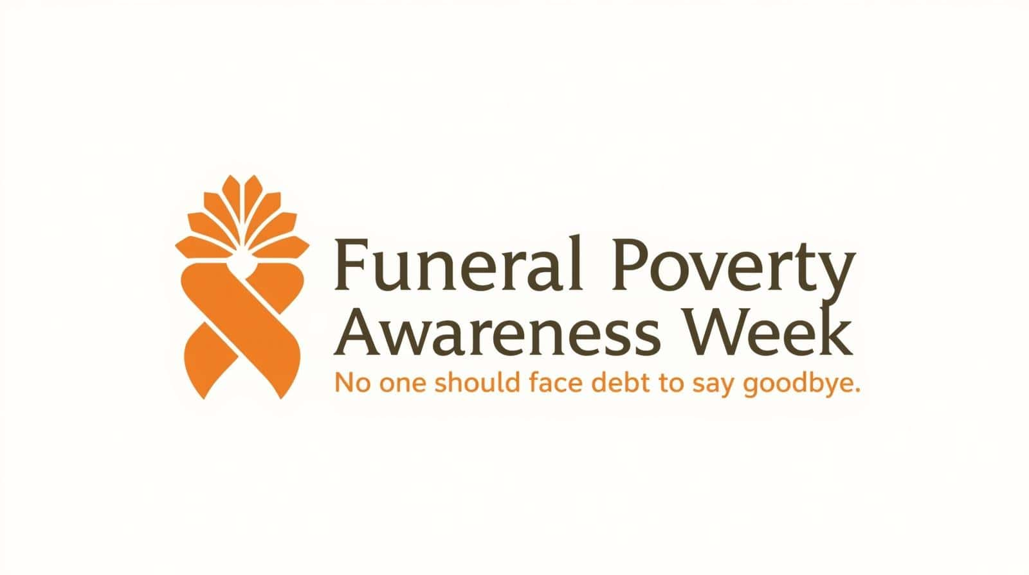
3–9 February
Social Media Toolkit
Ready-to-use posts for each day of the campaign
Day 1 (Monday 3 Feb) — The Cost of Saying Goodbye
LinkedIn / Facebook
The average funeral in the UK now costs over £4,000. For many families, this is a difficult sum to find at short notice. Funeral poverty is not just about money. It's about families being forced to make urgent decisions while grieving, often without clear information about costs or support available. This week is Funeral Poverty Awareness Week. We're raising awareness and calling for fairer pricing, better support, and improved signposting so families are not left facing debt just to say goodbye. #FuneralPovertyWeek #NoDebtToSayGoodbye
Twitter / X
The average funeral costs over £4,000. Many families struggle to meet this cost at short notice. This week is #FuneralPovertyWeek — raising awareness and calling for fairer systems and better support. #NoDebtToSayGoodbye
Day 2 (Tuesday 4 Feb) — Know Your Rights
LinkedIn / Facebook
Did you know? ✓ You can ask for an itemised quote from any funeral director ✓ You can compare prices — which can vary by hundreds of pounds ✓ You can say no to extras you don't need ✓ Financial help may be available Families deserve transparent pricing and clear choices. No one should feel pressured into costs they're unsure about or can't afford. Free guidance: 0800 086 8887 #FuneralPovertyWeek #KnowYourRights #FairFunerals
Twitter / X
Know your rights when arranging a funeral: ✓ Ask for itemised quotes ✓ Compare prices (they can vary) ✓ Say no to extras ✓ Check for financial help Free helpline: 0800 086 8887 #FuneralPovertyWeek #KnowYourRights
Day 3 (Wednesday 5 Feb) — Real Experiences
LinkedIn / Facebook
Many families don't realise how much flexibility there can be when arranging a funeral. We've supported people who believed they had no choice but to agree to very high costs, often because they didn’t want to feel they were letting a loved one down. Some also assume that financial help will be available afterwards — only to find this isn’t the case, or they miss out on benefits and grants they were entitled to. Without clear information at the right time, families can commit to costs they never expected to face alone. Earlier advice and better signposting can make a real difference — not just for funeral costs, but for maximising income through benefits, grants and other support. #FuneralPovertyWeek #NoDebtToSayGoodbye
Twitter / X
Many families don't realise funerals can be tailored, or assume help will be available later. Without clear advice at the right time, people can face unexpected costs and debt. #FuneralPovertyWeek #NoDebtToSayGoodbye
Day 4 (Thursday 6 Feb) — Managing Costs Safely
LinkedIn / Facebook
Struggling with funeral costs? Here are some safer steps to consider: ✓ Get more than one quote if you can ✓ Ask about payment options ✓ Check eligibility for benefits and grants — not just Funeral Expenses Payment, but other support you may be entitled to ✗ Avoid high-risk or illegal lenders Loan sharks target people at their most vulnerable. If someone offers cash with no paperwork, report them. Stop Loan Sharks helpline: 0300 555 2222 #FuneralPovertyWeek #NoDebtToSayGoodbye
Twitter / X
Struggling with funeral costs? ✓ Compare quotes ✓ Ask about payment options ✓ Check for benefits & grants ✗ Avoid loan sharks Report loan sharks: 0300 555 2222 #FuneralPovertyWeek #NoDebtToSayGoodbye
Day 5 (Friday 7 Feb) — Standing Up for Fair Funerals
LinkedIn / Facebook
We're calling for: • Clear and transparent funeral pricing • Better signposting to affordable options • Stronger enforcement of CMA pricing rules • Appropriate regulation and safeguarding • Protection from harmful lending Every family deserves dignity, clarity, and fair treatment when arranging a funeral. #FuneralPovertyWeek #FairFunerals
Twitter / X
We're calling for: • Transparent pricing • Clear information • Strong safeguards • Protection from debt Every family deserves dignity. #FuneralPovertyWeek #FairFunerals
Day 6 (Saturday 8 Feb) — Community Action
LinkedIn / Facebook
Funeral poverty affects communities everywhere. You can help by: • Sharing accurate information about support • Talking openly about funeral costs • Challenging stigma around affordable funerals • Supporting local advice and hardship services Together, we can reduce the risk of families facing unnecessary debt at a time of loss. #FuneralPovertyWeek #NoDebtToSayGoodbye
Twitter / X
You can help by: • Sharing support info • Talking about funeral costs • Challenging stigma Together, we can reduce harm and debt. #FuneralPovertyWeek #NoDebtToSayGoodbye
Day 7 (Sunday 9 Feb) — Reflection & Commitment
LinkedIn / Facebook
Funeral Poverty Awareness Week ends today — but the conversation continues.
With better information, earlier support, and fairer systems, families can be better protected from unnecessary financial hardship at a time of loss.
Thank you to everyone who has shared, supported, and spoken out this week.
If you need help: 0800 086 8887
#FuneralPovertyWeek #NoDebtToSayGoodbye #FairFunerals
Twitter / X
Better information. Earlier support. Fairer systems.
Thank you to everyone who supported #FuneralPovertyWeek.
The conversation continues and families shouldn’t face debt just to say goodbye.
Need help? 0800 086 8887
#NoDebtToSayGoodbye #FairFunerals
Free helpline: 0800 086 8887 | funeralexperts.com

